Why Motorcycles
are
INVISIBLE!

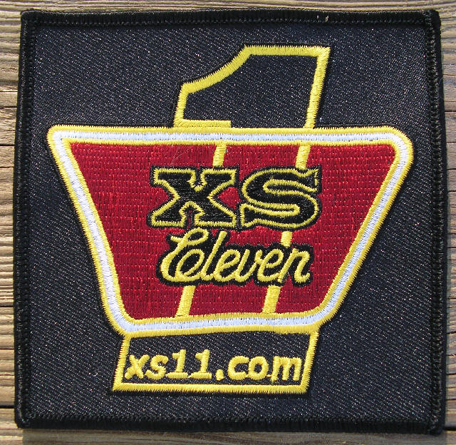

By T.C. Gresham
Edited by Marshall Ringler

I'm a Certified Ophthalmic Technician/Surgical Assistant with over 25 years of experience. I am at times required to fill out patient's DMV forms stating their visual function levels, so I am very familiar with the standards!
Most everybody knows that 20/20 vision is the accepted level for normal good vision, but what you may NOT know is that you are NOT required to have 20/20 vision to drive. The standards of vision in Best Corrected/wearing glasses values for driving across the USA are as follows:
20/40 vision and a peripheral field of vision of 100 degrees to have the ability to drive at NIGHT.
20/70 vision and a peripheral field of vision of 70 degrees to be allowed to drive in the DAYTIME.
Now the kicker...this is ONLY ONE EYE!! A person does not need to even have a second eye.
Commercial/CDL licenses DO require 20/40 best corrected in BOTH EYES, and 100 degrees of peripheral vision.
Some examples:
A healthy person's field of vision is approximately 180 degrees, from left ear to right ear when looking straight ahead.
Below is a view taken at a local intersection just standing in the driving lane:

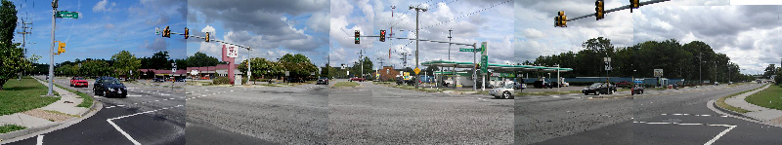
Now from INSIDE the Car:
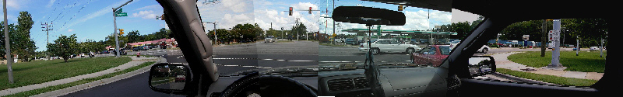

Now just showing the view to the left from the car, note the TREES, Signal Light Pole, Power Line Poles, etc.:
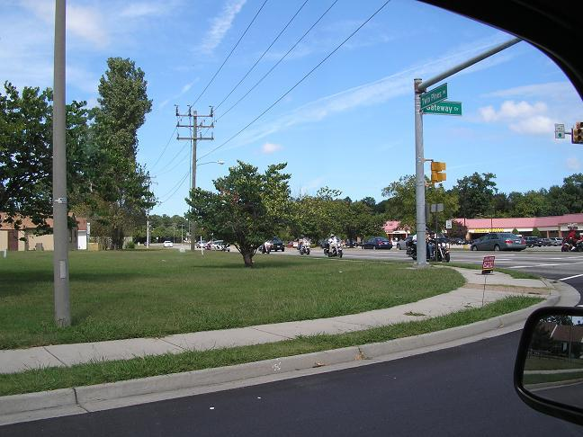
Here's a view pulling up to the crosswalk of the intersection:
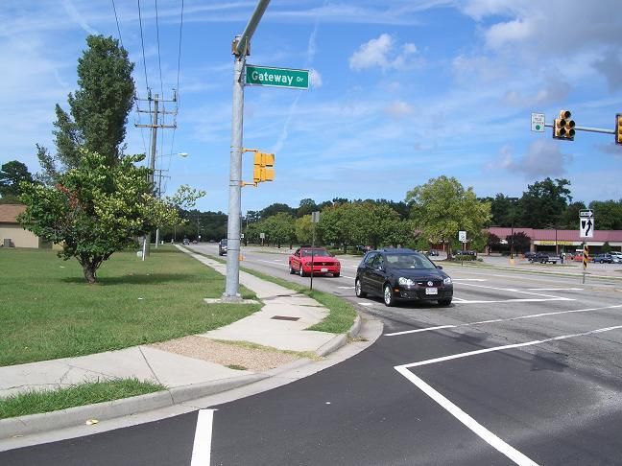
Now a zoomed in view, do you see the bike yet? It's on the sidewalk, but a full block away!
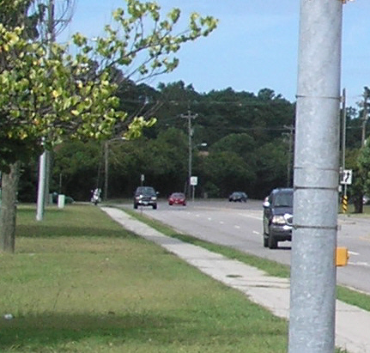

Now, just a few examples of comparing the view/size of a standard SUV...
A Nissan Xterra and a motorcycle (note that this one has saddlebags, adding to the width of the bike):
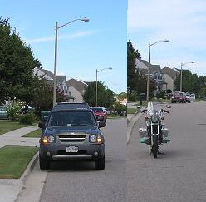
Now 100 feet away:
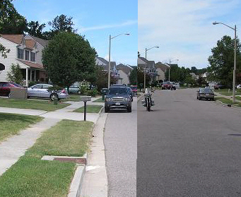

Now 200 feet away:
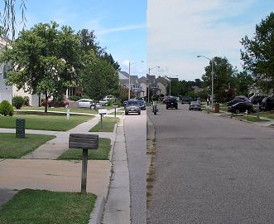
And below is a shot of my bike below a standard Speed Limit Sign. The size of the lettering for the words Speed Limit are about 4" tall, which is just a bit over the 20/200 size lettering we use for vision exams, and this photo was taken at 200 feet:
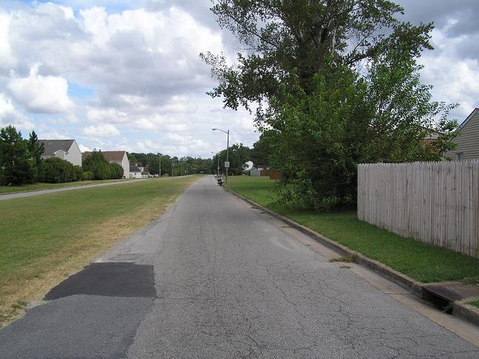
Some more background info:
The visual acuity letter sizes were determined over a 100 years ago, calculated on the density and size of the individual light receptors (rods and cones) and so 20/20 was found to be about a 1/12th of a degree of visual field. Remember, 180 degrees or a semicircle of vision is what we have looking forward with both eyes. The fields of vision overlap with our two eyes, approx. 45 degrees towards the nose for each eye. This gives us approximately 90 degrees of both-eyes vision. This is what also gives us TRUE 3-D stereo vision/depth perception.
Below is an example of this with vertical red lines marking the 45 degrees to either side of center of overlapped vision. But note how much to the side is only seen by 1 eye:
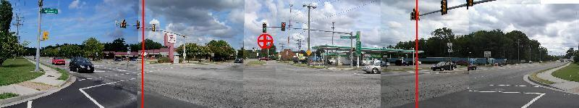
Some more examples of reduced peripheral vision:
View of approximately 100 degrees of peripheral vision:
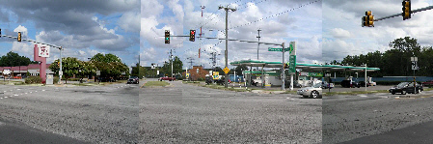
View of approximately 70 degrees of peripheral vision:
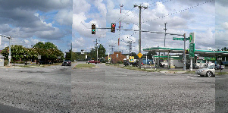

MATH: To determine how big a person’s peripheral "BLUR" area would be according to their visual acuity at specific distances. These sizes are NOT totally blind areas, but are the size that an object could be and NOT be discernible or able to tell what it is at these distances.
20/40=1/6th deg; 20/70= 1/3rd deg; 20/200=4/5th deg.
I used basic math:
Circle's circumference= Diameter X ∏=360 degrees
1/2 circumference= 1/2 diameter or Radius X ∏=180 degree
Radius 20ft X 12" X ∏=~754" 180 deg
1 degree = 4.18" at 20feet.
This same formula was used for the 50ft, 100ft, 200ft, and 500ft distances.
Blur Area Size and Distances
Visual 20feet 100feet 200feet 500feet
Acuity
20/20 0.35in 1.7in 3.36in 8.4in
20/40 0.63in 2.1in 6.3in 15.7in
20/70 1.14in 6.3in 12.6in 31.5in
20/200 3.25in 16.8in 33.6in 84 in
Other sizes of interest:
Yamaha XS1100 (average sized Cruiser Motorcycle), Not including a fairing, with rider: approximately 2ft wide x 5ft high = 10 sq. feet area.
Nissan Xterra (average sized modern SUV): approximately 5ft wide x 6ft high = 30 sq. feet area.
Most in town residential traffic is 35mph, maybe 45mph for city. A vehicle at that speed covers 50ft a second. A common block length as ~500 feet, or 1/10th a mile, and will be travelled in 10 seconds, quicker if the vehicle is travelling faster, of course!

Now a few shots at the very edge of the intersection like someone would do before turning right. The bike again is a FULL BLOCK away, on the sidewalk. Just 10 seconds away at 35mph.
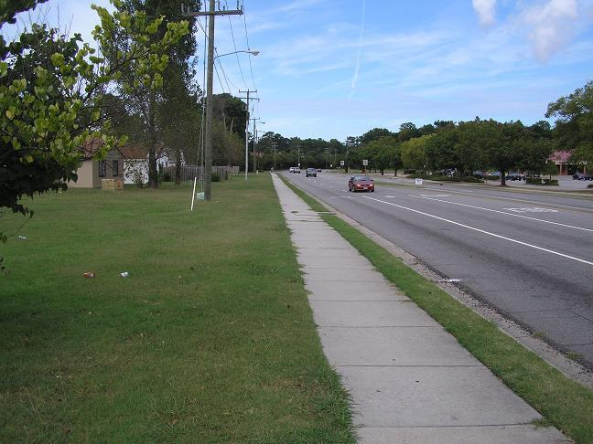
A zoomed in view:
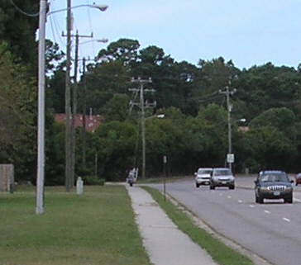
Here it is ONLY 1/2 block away, a mere 5 seconds away at 35mph:
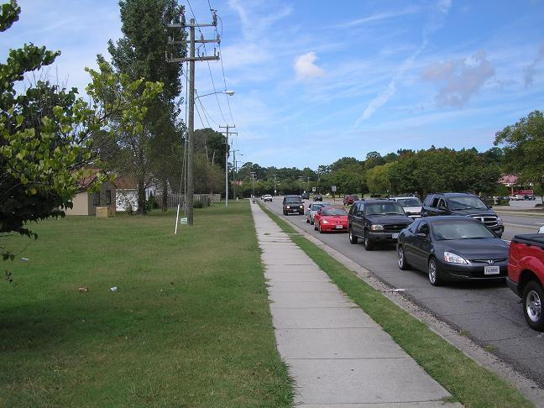
And a zoomed in view:
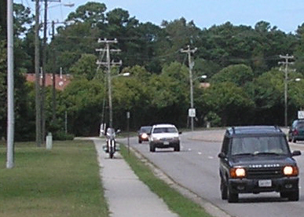
So, now looking back at the blur sizes for certain visions at certain distances, a person with 20/20 could have trouble seeing something that is ~8.4" wide. The size of an average round headlight is 7"! A person with the bare minimum 20/70 vision could not discern an object 31.5" wide. Remember - we are about 24" wide!
Oh, but there's more!! The human eye has a Natural Blind Spot in it. It's where the optic nerve plugs into the eye, all of the millions of fibers span out from this location to map out the eye's vision, but this area itself can not see. It's about 10 degrees wide by 15 degrees high, and just 10 degrees towards the ear from center of each eye. We usually never see it because the other eye's retina sees for it. Here's an example looking straight ahead. Notice how big they are in relation to that TRUCK!
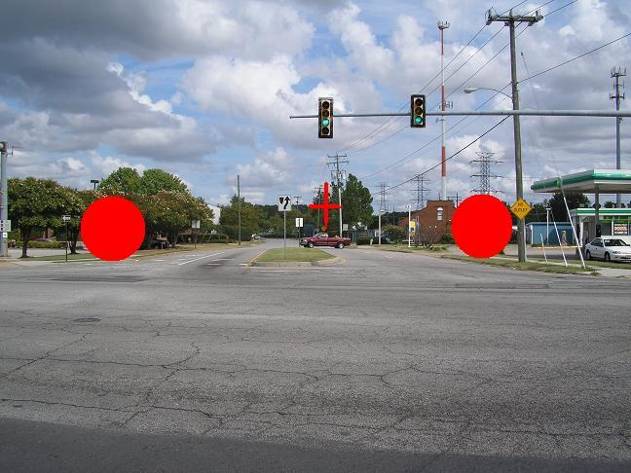
These spots' locations are in reference to the actual photo, not to you sitting here looking at this page. HOWEVER, if this page is a standard 8.5”X11”, and you hold the page about 18-20" away from your face, you can cover your right eye and look at the RIGHT dot with your Left eye, and the LEFT red dot will disappear! Vice versa for the other eye. You may have to move inward or outward a little depending on the size of this page.

Our population is aging, their eyesight is failing, their bodies and necks are stiff, and people are often in a hurry, so they don't often bother turning their heads very far left or right to check down the road. So, IF they turn their heads just 30 degrees left, their right eyes 45 degrees of nose side vision will NOT cover the full 80-90 degrees left view down the road, and so their natural BLIND spot can occlude a fairly large area and won't be seen by the right eye, and you can have this situation!
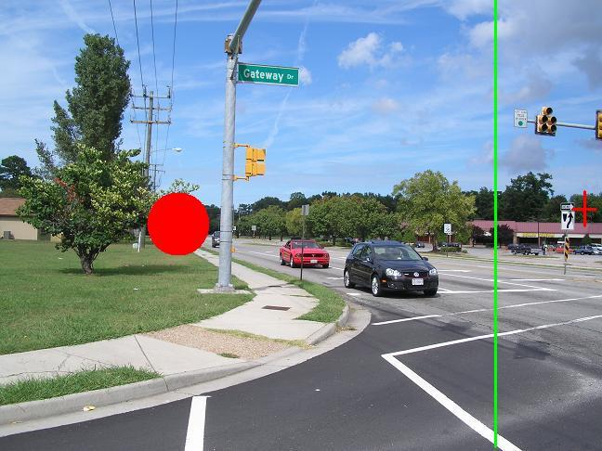

So, in conclusion, it is always best to ride as though
YOU ARE INVISIBLE.

